**A  
PROJECT REPORT  
ON**

**DENTIST WEBSITE  
IN HTML & CSS**

Submitted in partial fulfillment of the requirement  
for the award of the BCA Vth Semester  
  
**MAA SHAKUMBHARI UNIVERSITY**

**SAHARNPUR**

jsjsj



**Submitted By:-**

**Name:-Mohd UZZAIR**

**Roll No. :-210954106054**

**D.A.V.(P.G.) COLLEGE,**

MUZAFFARNAGAR 251001

**“CARTIFICATE”**

It is certify that **Mohd Uzzair s/o Sattar Ali** student of **BCA-5TH of D.A.V(P.G) COLLEGE MUZAFFARNAGAR** has completed the project file on “Minor Project” under the guidance of **MRS.VISHALNI.**

This Project File is a part of course curriculum

We found the practical file satisfactory and we wish her bright future for his/her career.

**Mrs. Vishalni**

**DECLARATION**

We hereby declare that the project work entitled **“ DENTIST WEBSITE”** submitted to the DAV College Muzaffarnagar is a record of an original work done by **MOHD UZZAIR** under the guidance of **Mrs. Vishalni** this project work is submitted in the partial fulfilment of the requirements for the award of the Bachelor of Computer Application.

MOHD UZZAIR

**ACKNOWLEDGEMENT**

We would like to express our greatest appreciation to the all individuals who have helped and supported us throughout the project. We are thankful to our computer teacher for his ongoing support during the project, from initial advice, and encouragement, which led to the final report of this project on “DENTIST WEBSITE”.

A special acknowledgement goes to our classmates who helped us in completing the project by exchanging interesting ideas and sharing their experience.

We wish to thank our parents as well for their undivided support and interest who inspired us and encouraged us to go our own way, without whom We would be unable to complete our project.

At the end, we would like to thank our friends who displayed appreciation to our work and motivated us to continue our work.

MOHD UZZAIR

**CONTENTS**

* Front Page
* College Certificate
* Declaration
* Acknowledgement
* Contents
* Preface
* Introduction About the Project
* Hardware & Software Requirement
* Relationship Between Webpages
* Data Flow Diagrams
* Data Dictionary
* List of tables
* Introduction To Html & Css
* Source Code
* Snapshots (From Design)
* Implementation
* Maintenance
* Conclusion & Future Scope
* Bibliography

**PREFACE**

We herby declare that the work which is being presented in the project entitled **“DENTIST WEBSITE”** is an authentic work carried out by us under guidance of **Mrs.Vishalni** of **D.A.V.(P.G.) College Muzaffarnagar.**

This project will work as reference to use the software**“DENTIST WEBSITE”.**

We had tried our best to keep it error free still. Perfection cannot be claim by humans.

**MOHD UZZAIR**

INTRODUCTION ABOUT  
 THE PROJECT

**DENTIST WEBSITE:**

A dentist is a healthcare provider who diagnoses and treats oral health conditions. Taking good care of your teeth and gums can help you reduce your risk for other serious health conditions, like heart disease and stroke. You should visit a dentist regularly for routine exams and cleanings.

A dentist -sometimes called a general dentist or family dentist –is a healthcare provider who diagnoses and treats oral health conditions. Dentists help keep your teeth and gums healthy with regular dental check-ups and cleanings. They can also perform a variety of oral health treatments, including dental fillings, crowns and bridges.

**MAIN OBJECTIVE OF THIS PROJECT:**

• Provide the searching facilities based on various factors. Such as Dentist clinic, Patient, Test, Appointment.

• To help the doctor in working easy and

efficiently.

• To manage the information of doctor.

• To increase efficiency of managing the dental Doctor.

• To manage the information of doctor.

**NECESSITY OF USING THE WEBSITE:**

**Appointment booking:** Many patients prefer the convenience of booking appointment online. With a website, you can integrate appointment scheduling tools, allowing patient to book appointments at their convenience. This not only enhances the patient experience but also streamlines your practice’s scheduling process.

Patients, both potential and existing, want to schedule their appointments online. Even more than that, the vast majority of them most likely expect it.

Another benefit of your dental website is that it is available to you around the clock, and the addition of a scheduling tool gives you the ability to book appointments at any time of day or night. Patients will value convenience, and your staff will value the reduction in the number of phone calls received.

**Create & improve personal visibility:**

When individuals are looking for a dentist who can provide them with treatment, they want to make sure that the dentist is reliable before making an appointment with them. This is important not only for you but also for the potential new patient, as it allows you to build trust with the patient while also providing you with the opportunity to explain how you and your practice operate, as well as your educational background, specializations, and other relevant information.

When booking an appointment with you, this makes first-time patients feel less anxious and more at ease.

**Online Visibility:** A website makes your dental practice visible to potential patients who search for dental services online. It allows you to establish an online presence and attract new patients. Information Hub: Your website serves as a central hub for information about your practice, including services offered, staff bios, office hours, contact information, and location.

**Appointment Scheduling:** Patients can easily schedule appointments online, which improves convenience for both patients and your staff.

**Educational Resource:** You can use your website to educate patients about various dental procedures, oral health tips, and frequently asked questions.

**Credibility:** A professionally designed website instills trust and credibility in potential patients. It shows that you take your practice seriously and are invested in providing quality care.

**Competitive Advantage:** In today's digital age, having a website sets you apart from competitors who may not have an online presence or whose websites are outdated.

**Communication:** Your website allows you to communicate important updates, such as office closures, new services, or promotions, to your patients.

Overall, a dentist website is essential for attracting new patients, providing information, and enhancing patient experience and satisfaction.

**SOFTWARE & HARDWARE  
REQUIREMENTS**

* **Hardware Requirements:**

Processor : Pentium 4 or above

Memory : 2 GB RAM or above Hard disk : 20 MB or above

Keyboard : 108 keys

Monitor: SVGA Color

Mouse:PS/2, USB

* **Software Requirements:**

Operating System: Any Windows /Mac

Connection: TCP/IP

Programming Language: Html & Css

Protocol:HTTP,SMTP,POP3,WAP

**Relationship Between**

**Webpages**

Webpages can have various relationships depending on how they are interconnected. Common relationships between webpages include:

**Hyperlinks:** Webpages often link to each other through hyperlinks, creating a network of interconnected content on the web.

**Hierarchy:** Some webpages are organized hierarchically, with parent pages linking to child pages, creating a structured relationship.

**Navigation:** Webpages within the same website often have navigational links that allow users to move between them easily, establishing a navigational relationship.

**Related Content:** Websites may have sections or pages dedicated to related content, such as a blog post linking to related articles, establishing thematic relationships.

**References:** Academic or informational websites may cite or reference other webpages, establishing a scholarly relationship.

**Social Connections:** Webpages may be connected through social media platforms, where users share and interact with content, creating social relationships between webpages.

**Design and Layout:** Consistent design elements and layout across web pages can reinforce their relationship within a website and help users understand where they are in the site's structure.

Understanding these relationships is essential for creating a cohesive and user-friendly website navigation experience.

Overall, the relationship between webpages is dynamic and multifaceted, influenced by factors such as content, context, and user interaction.

**INTRODUCTION TO HTML  
& CSS**

## What is HTML?

HTML is the standard markup language for creating Web pages.

* HTML stands for Hyper Text Markup Language
* HTML describes the structure of Web pages using markup
* HTML elements are the building blocks of HTML pages
* HTML elements are represented by tags
* HTML tags label pieces of content such as "heading", "paragraph", "table", and so on
* Browsers do not display the HTML tags, but use them to render the content of the page

HTML is a computer language devised to allow website creation. These websites can then be viewed by anyone else connected to the Internet. It is relatively **easy to learn**, with the basics being accessible to most people in one sitting; and quite **powerful** in what it allows you to create. It is constantly undergoing revision and evolution to meet the demands and requirements of the growing Internet audience under the direction of the [**» W3C**](http://www.w3.org/), the organisation charged with designing and maintaining the language.

The definition of HTML is **HyperText Markup Language**.

* *HyperText* is the method by which you move around on the web — by clicking on special text called **hyperlinks** which bring you to the next page. The fact that it is*hyper* just means it is not linear — i.e. you can go to any place on the Internet whenever you want by clicking on links — there is no set order to do things in.
* *Markup* is what **HTML tags** do to the text inside them. They mark it as a certain type of text (*italicised* text, for example).
* HTML is a *Language*, as it has code-words and syntax like any other language.How does it work?
* HTML consists of a series of short **codes** typed into a text-file by the site author — these are the tags. The text is then **saved as a html file**, and **viewed through a** [browser](http://www.yourhtmlsource.com/starthere/glossary.html#browser), like Internet Explorer or Netscape Navigator. This browser reads the file and translates the text into a visible form, hopefully rendering the page as the author had intended. Writing your own HTML entails using tags correctly to create your vision. You can use anything from a rudimentary text-editor to a powerful graphical editor to create HTML pages.

**css:**

**Cascading Style Sheets**, fondly referred to as CSS, is a simple design language intended to simplify the process of making web pages presentable.

CSS handles the look and feel part of a web page. Using CSS, you can control the color of the text, the style of fonts, the spacing between paragraphs, how columns are sized and laid out, what background images or colors are used, layout designs,variations in display for different devices and screen sizes as well as a variety of other effects.

CSS is easy to learn and understand but it provides powerful control over the presentation of an HTML document. Most commonly, CSS is combined with the markup languages HTML or XHTML.

## Advantages of CSS

* **CSS saves time** − You can write CSS once and then reuse same sheet in multiple HTML pages. You can define a style for each HTML element and apply it to as many Web pages as you want.
* **Pages load faster** − If you are using CSS, you do not need to write HTML tag attributes every time. Just write one CSS rule of a tag and apply it to all the occurrences of that tag. So less code means faster download times.
* **Easy maintenance** − To make a global change, simply change the style, and all elements in all the web pages will be updated automatically.
* **Superior styles to HTML** − CSS has a much wider array of attributes than HTML, so you can give a far better look to your HTML page in comparison to HTML attributes.
* **Multiple Device Compatibility** − Style sheets allow content to be optimized for more than one type of device. By using the same HTML document, different versions of a website can be presented for handheld devices such as PDAs and cell phones or for printing.
* **Global web standards** − Now HTML attributes are being deprecated and it is being recommended to use CSS. So its a good idea to start using CSS in all the HTML pages to make them compatible to future browsers.
* **Offline Browsing** − CSS can store web applications locally with the help of an offline catche.Using of this, we can view offline websites.The cache also ensures faster loading and better overall performance of the website.
* **Platform Independence** − The Script offer consistent platform independence and can support latest browsers as well.

## Who Creates and Maintains CSS?

CSS was invited by **Håkon Wium Lie** on October 10, 1994 and maintained through a group of people within the W3C called the CSS Working Group. The CSS Working Group creates documents called **specifications**. When a specification has been discussed and officially ratified by W3C members, it becomes a recommendation.

These ratified specifications are called recommendations because the W3C has no control over the actual implementation of the language. Independent companies and organizations create that software.

**NOTE** − The World Wide Web Consortium, or W3C is a group that makes recommendations about how the Internet works and how it should evolve.

## CSS Versions

Cascading Style Sheets, level 1 (CSS1) was came out of W3C as a recommendation in December 1996. This version describes the CSS language as well as a simple visual formatting model for all the HTML tags.

CSS2 was became a W3C recommendation in May 1998 and builds on CSS1. This version adds support for media-specific style sheets e.g. printers and aural devices, downloadable fonts, element positioning and tables.

CSS3 was became a W3C recommendation in June 1999 and builds on older versions CSS. it has divided into documentations is called as Modules and here each module having new extension features defined in CSS2.

**SOURCE CODE**

**Html:**

<!DOCTYPE html>

<html lang="en">

<head>

<meta charset="UTF-8">

<meta http-equiv="X-UA-Compatible" content="IE=edge">

<meta name="viewport" content="width=device-width, initial-scale=1.0">

<title>Responsive Dentist Website</title>

<!-- font awesome cdn link -->

<link rel="stylesheet" href="https://cdnjs.cloudflare.com/ajax/libs/font-awesome/6.0.0/css/all.min.css">

<!-- swiper css link -->

<link rel="stylesheet" href="https://unpkg.com/swiper@7/swiper-bundle.min.css" />

<!-- custom css file link -->

<link rel="stylesheet" href="style.css">

</head>

<body>

<header class="header">

<a href="#" class="logo"> <i class="fas fa-tooth"></i> dentist </a>

<nav class="navbar">

<a href="#home">home</a>

<a href="#about">about</a>

<a href="#services">services</a>

<a href="#team">team</a>

<a href="#pricing">pricing</a>

<a href="#blog">blog</a>

</nav>

<a href="#" class="btn"> make appointment </a>

<div id="menu-btn" class="fas fa-bars"></div>

</header>

**<!-- header end -->**

**<!-- home -->**

<section class="home" id="home">

<div class="content">

<h3>make your smile shine</h3>

<p>Lorem ipsum dolor sit amet consectetur, adipisicing elit. Deleniti, dolores. Ad rerum eum assumenda mollitia autem quo nulla, consequatur quisquam est? Dolorem fugiat fugit amet dolores provident velit eos est.</p>

<a href="#" class="btn">make appointment</a>

</div>

</section>

**<!-- home end -->**

**<!-- about us section-->**

<section class="about" id="about">

<h1 class="heading"> about us </h1>

<div class="row">

<div class="image">

<img src="images/about.webp" alt="">

</div>

<div class="content">

<h3>our clinic is made for you to be smiling all the time</h3>

<p>Lorem ipsum dolor sit amet consectetur adipisicing elit. Voluptate inventore explicabo recusandae cumque dolor voluptas nihil.</p>

<p>Lorem ipsum dolor sit amet consectetur adipisicing elit. Voluptate inventore explicabo recusandae cumque dolor voluptas nihil.</p>

<a href="#" class="btn">read more</a>

</div>

</div>

</section>

**<!-- about end -->**

**<!-- services -->**

<section class="services" id="services">

<h1 class="heading"> our services</h1>

<div class="box-container">

<div class="box">

<img src="images/services-1.webp" alt="">

<h3>online schedule</h3>

<p>Lorem ipsum dolor, sit amet consectetur adipisicing elit. Omnis in excepturi.</p>

</div>

<div class="box">

<img src="images/services-2.webp" alt="">

<h3>cosmetic feeling</h3>

<p>Lorem ipsum dolor, sit amet consectetur adipisicing elit. Omnis in excepturi.</p>

</div>

<div class="box">

<img src="images/services-3.webp" alt="">

<h3>oral hygiene experts</h3>

<p>Lorem ipsum dolor, sit amet consectetur adipisicing elit. Omnis in excepturi.</p>

</div>

</div>

</section>

**<!-- services end-->**

**<!-- team section -->**

<section class="team" id="team">

<h1 class="heading"> our team</h1>

<div class="swiper team-slider">

<div class="swiper-wrapper">

<div class="swiper-slide slide">

<div class="image">

<img src="images/team-1.jpg" alt="">

<div class="share">

<a href="#" class="fab fa-facebook-f"></a>

<a href="#" class="fab fa-twitter"></a>

<a href="#" class="fab fa-instagram"></a>

<a href="#" class="fab fa-linkedin"></a>

</div>

</div>

<div class="content">

<h3>john lacy</h3>

<span>genral surgeon</span>

</div>

</div>

<div class="swiper-slide slide">

<div class="image">

<img src="images/team-2.jpg" alt="">

<div class="share">

<a href="#" class="fab fa-facebook-f"></a>

<a href="#" class="fab fa-twitter"></a>

<a href="#" class="fab fa-instagram"></a>

<a href="#" class="fab fa-linkedin"></a>

</div>

</div>

<div class="content">

<h3>john lacy</h3>

<span>genral surgeon</span>

</div>

</div>

<div class="swiper-slide slide">

<div class="image">

<img src="images/team-3.jpg" alt="">

<div class="share">

<a href="#" class="fab fa-facebook-f"></a>

<a href="#" class="fab fa-twitter"></a>

<a href="#" class="fab fa-instagram"></a>

<a href="#" class="fab fa-linkedin"></a>

</div>

</div>

<div class="content">

<h3>john lacy</h3>

<span>genral surgeon</span>

</div>

</div>

<div class="swiper-slide slide">

<div class="image">

<img src="images/team-4.jpg" alt="">

<div class="share">

<a href="#" class="fab fa-facebook-f"></a>

<a href="#" class="fab fa-twitter"></a>

<a href="#" class="fab fa-instagram"></a>

<a href="#" class="fab fa-linkedin"></a>

</div>

</div>

<div class="content">

<h3>john lacy</h3>

<span>genral surgeon</span>

</div>

</div>

</div>

</div>

</section>

**<!-- team section ends -->**

**<!-- pricing plan -->**

<section class="pricing" id="pricing">

<h1 class="heading">pricing plan</h1>

<div class="box-container">

<div class="box">

<h3 class="title">basic</h3>

<div class="price">

<span class="currency">$</span>

<span class="amount">18</span>

<span class="duration"> /year</span>

</div>

<ul>

<li> <i class="fas fa-check"></i> alignment specialist</li>

<li> <i class="fas fa-check"></i> cavity inspection</li>

<li> <i class="fas fa-check"></i> cosmetic dentistry</li>

<li> <i class="fas fa-check"></i> oral hygiene experts</li>

</ul>

<a href="#" class="btn">read more </a>

</div>

<div class="box active">

<h3 class="title">standard</h3>

<div class="price">

<span class="currency">$</span>

<span class="amount">30</span>

<span class="duration"> /year</span>

</div>

<ul>

<li> <i class="fas fa-check"></i> alignment specialist</li>

<li> <i class="fas fa-check"></i> cavity inspection</li>

<li> <i class="fas fa-check"></i> cosmetic dentistry</li>

<li> <i class="fas fa-check"></i> oral hygiene experts</li>

</ul>

<a href="#" class="btn">read more </a>

</div>

<div class="box">

<h3 class="title">premium</h3>

<div class="price">

<span class="currency">$</span>

<span class="amount">50</span>

<span class="duration"> /year</span>

</div>

<ul>

<li> <i class="fas fa-check"></i> alignment specialist</li>

<li> <i class="fas fa-check"></i> cavity inspection</li>

<li> <i class="fas fa-check"></i> cosmetic dentistry</li>

<li> <i class="fas fa-check"></i> oral hygiene experts</li>

</ul>

<a href="#" class="btn">read more </a>

</div>

</div>

</section>

**<!-- pricing plan ends -->**

**<!-- blog -->**

<section class="blog" id="blog">

<h1 class="heading">our blogs</h1>

<div class="box-container">

<div class="box">

<div class="image">

<img src="images/blog-1.jpg" alt="">

</div>

<div class="content">

<a href="#" class="link">Diease</a>

<div class="icons">

<a href="#"> <i class="fas fa-calendar"></i> 04th september, 2022 </a>

<a href="#"> <i class="fas fa-user"></i> by admin</a>

</div>

<h3>the most common problems?</h3>

<p>Lorem ipsum dolor, sit amet consectetur adipisicing elit. At cum atque sed veniam sunt, maxime natus excepturi maiores voluptatum.</p>

<a href="#" class="btn">read more</a>

</div>

</div>

<div class="box">

<div class="image">

<img src="images/blog-2.jpg" alt="">

</div>

<div class="content">

<a href="#" class="link">Diease</a>

<div class="icons">

<a href="#"> <i class="fas fa-calendar"></i> 04th september, 2022 </a>

<a href="#"> <i class="fas fa-user"></i> by admin</a>

</div>

<h3>the most common problems?</h3>

<p>Lorem ipsum dolor, sit amet consectetur adipisicing elit. At cum atque sed veniam sunt, maxime natus excepturi maiores voluptatum.</p>

<a href="#" class="btn">read more</a>

</div>

</div>

<div class="box">

<div class="image">

<img src="images/blog-3.jpg" alt="">

</div>

<div class="content">

<a href="#" class="link">Diease</a>

<div class="icons">

<a href="#"> <i class="fas fa-calendar"></i> 04th september, 2022 </a>

<a href="#"> <i class="fas fa-user"></i> by admin</a>

</div>

<h3>the most common problems?</h3>

<p>Lorem ipsum dolor, sit amet consectetur adipisicing elit. At cum atque sed veniam sunt, maxime natus excepturi maiores voluptatum.</p>

<a href="#" class="btn">read more</a>

</div>

</div>

</div>

</section>

**<!-- blog ends -->**

<!-- contact -->

<section class="contact" id="contact">

<h1 class="heading">make appointment</h1>

<form action="">

<span>your name :</span>

<div class="inputBox">

<input type="text" placeholder="first name">

<input type="text" placeholder="last name">

</div>

<span>your email :</span>

<input type="email" placeholder="enter your email" class="box">

<span>your number :</span>

<input type="number" placeholder="enter your number" class="box">

<span>appointment date :</span>

<input type="datetime-local" class="box">

<input type="submit" value="order now" class="btn">

</form>

</section>

**<!-- contact ends-->**

**<!-- footer -->**

<section class="footer">

<div class="box-container">

<div class="box">

<h3>address</h3>

<p>Lorem ipsum dolor sit amet consectetur adipisicing elit. Ipsa ex placeat.</p>

<div class="share">

<a href="#" class="fab fa-facebook-f"></a>

<a href="#" class="fab fa-twitter"></a>

<a href="#" class="fab fa-linkedin"></a>

<a href="#" class="fab fa-instagram"></a>

</div>

</div>

<div class="box">

<h3>e-mail</h3>

<a href="#" class="link">ninjashub4@gmail.com</a>

<a href="#" class="link">ninjashub4@gmail.com</a>

</div>

<div class="box">

<h3>call us</h3>

<p>+61 (0) 3 2587 4569</p>

<p>+61 (0) 3 2587 4569</p>

</div>

<div class="box">

<h3>opening hours</h3>

<p>monday - friday : 8:00 - 24:00 <br>

saturday : 9:00 - 24:00

</p>

</div>

</div>

<div class="credit">created by <span>ninjashub</span> | all rights reserved!</div>

</section>

**<!-- footer ends -->**

<!-- swiper js link -->

<script src="https://unpkg.com/swiper@7/swiper-bundle.min.js"></script>

<!-- custom js file link -->

<script src="script.js"></script>

</body>

</html>

**CSS:**

@import url('https://fonts.googleapis.com/css2?family=Poppins:wght@100;200;300;400;500;600&display=swap');

:root{

--primary:#1f2e88;

--secondary:#2f66d4;

--hover: #a2d9f5;

--black:#333;

--white:#fff;

--light-color:#666;

--light-bg:#eee;

--border:.2rem solid rgba(0,0,0,.1);

--box-shadow:0 .5rem 1rem rgba(0,0,0,.1);

}

*{

font-family: 'Poppins', sans-serif;

margin: 0; padding: 0;

box-sizing: border-box;

outline: none; border: none;

text-decoration: none;

text-transform: capitalize;

transition: .2s linear;

}

html{

font-size: 62.5%;

overflow-x: hidden;

scroll-padding-top: 9rem;

scroll-behavior: smooth;

}

html::-webkit-scrollbar{

width: .8rem;

}

html::-webkit-scrollbar-track{

background: transparent;

}

html::-webkit-scrollbar-thumb{

background: var(--primary);

border-radius: 5rem;

}

section{

padding: 5rem 7%;

}

.heading{

font-size: 4rem;

text-align: center;

color: var(--black);

text-transform: uppercase;

font-weight: bolder;

margin-bottom: 3rem;

}

.btn{

margin-top: 1rem;

display: inline-block;

padding: 1rem 3rem;

border-radius: .5rem;

background: var(--primary);

cursor: pointer;

font-size: 1.7rem;

color: var(--white);

}

.btn:hover{

background: var(--secondary);

}

**/* header */**

.header{

position: fixed;

top: 0; left: 0; right: 0;

z-index: 1000;

background: var(--white);

box-shadow: var(--box-shadow);

display: flex;

align-items: center;

justify-content: space-between;

padding: 2rem 9%;

}

.header .logo{

font-size: 2.5rem;

font-weight: bolder;

color: var(--black);

}

.header .logo i{

color: var(--primary);

padding-right: .5rem;

}

.header .navbar a{

font-size: 1.7rem;

color: var(--black);

margin: 0 1rem;

}

.header .navbar a:hover{

color: var(--primary);

}

.header .btn{

margin-top: 0;

}

#menu-btn{

font-size: 2.5rem;

cursor: pointer;

color: var(--black);

margin-left: 1.7rem;

display: none;

}

#menu-btn:hover{

color: var(--primary);

}

**/* header end */**

**/* home */**

.home{

min-height: 100vh;

display: flex;

align-items: center;

background: url(../images/home.jpg) no-repeat;

background-size: cover;

background-position: center;

}

.home .content{

max-width: 60rem;

padding-left: 6rem;

padding-top: 10rem;

}

.home .content h3{

font-size: 6rem;

color: var(--black);

line-height: 1.2;

}

.home .content p{

line-height: 2;

font-size: 1.5rem;

color: var(--light-color);

padding: 1rem 0;

}

**/* home end */**

**/* about us */**

.about .row{

display: flex;

align-items: center;

flex-wrap: wrap;

gap: 2rem;

}

.about .row .image{

flex: 1 1 40rem;

}

.about .row .image img{

width: 100%;

height: 100%;

}

.about .row .content{

flex: 1 1 40rem;

}

.about .row .content h3{

color: var(--black);

font-size: 3.5rem;

line-height: 1.5;

}

.about .row .content p{

font-size: 1.4rem;

color: var(--light-color);

padding: 1rem 0;

line-height: 2;

}

**/* about end */**

**/* services */**

.services{

background: var(--light-bg);

}

.services .box-container{

display: grid;

grid-template-columns: repeat(auto-fit, minmax(30rem, 1fr));

gap: 2rem;

}

.services .box-container .box{

padding: 4rem;

text-align: center;

background: var(--white);

box-shadow: var(--box-shadow);

border-radius: 5rem;

}

.services .box-container .box:hover{

background: var(--hover);

}

.services .box-container .box img{

margin: 1rem 0;

height: 10rem;

}

.services .box-container .box h3{

font-size: 2rem;

padding: 1rem 0;

color: var(--black);

}

.services .box-container .box p{

font-size: 1.5rem;

color: var(--light-color);

line-height: 2;

}

**/* services section ends */**

**/* team section */**

.team .slide{

text-align: center;

}

.team .slide .image{

position: relative;

overflow: hidden;

}

.team .slide .image img{

width: 100%;

}

.team .slide .image .share{

padding: 2rem;

position: absolute;

bottom: -10rem;

left: 0; right: 0;

background: rgba(0,0,0,.8);

}

.team .slide:hover .image .share{

bottom: 0;

}

.team .slide .image .share a{

font-size: 3rem;

margin: 0 1rem;

color: var(--white);

}

.team .slide .image .share a:hover{

color: var(--secondary);

}

.team .slide .content{

display: flex;

padding-top: 1rem;

align-items: center;

justify-content: space-between;

}

.team .slide .content h3{

font-size: 2rem;

color: var(--black);

}

.team .slide .content span{

font-size: 1.5rem;

line-height: 2;

color: var(--light-color);

}

**/* team section ends */**

.pricing{

background: var(--light-bg);

}

.pricing .box-container{

display: flex;

flex-wrap: wrap;

align-items: center;

justify-content: center;

}

.pricing .box-container .box{

height: 46rem;

width: 30rem;

margin: 2rem 4rem;

border-radius: 1rem;

box-shadow: var(--box-shadow);

text-align: center;

overflow: hidden;

position: relative;

z-index: 1;

background: var(--white);

}

.pricing .box-container .active{

background: var(--hover);

}

.pricing .box-container .box .title{

margin: 3rem 0;

font-size: 2.2rem;

color: var(--black);

text-transform: uppercase;

}

.pricing .box-container .box .price{

color: var(--primary);

margin-bottom: 5rem;

}

.pricing .box-container .box .price .currency{

font-size: 4rem;

line-height: 3.5rem;

font-weight: 300;

}

.pricing .box-container .box .price .amount{

font-size: 5.8rem;

line-height: 4.5rem;

font-weight: 700;

}

.pricing .box-container .box .price .duration{

font-size: 1.8rem;

font-weight: 400;

letter-spacing: .2rem;

}

.pricing .box-container .box ul li{

text-align: left;

font-size: 1.6rem;

padding-left: 3.5rem;

margin: 2rem auto;

color: var(--light-color);

text-transform: uppercase;

}

.pricing .box-container .box ul li i{

padding: 0 1rem;

color: var(--secondary);

}

**/* pricing plan ends */**

**/* blog */**

.blog .box-container{

display: grid;

grid-template-columns: repeat(auto-fit, minmax(30rem, 1fr));

gap: 1.5rem;

}

.blog .box-container .box{

border: var(--border);

}

.blog .box-container .box .image{

height: 25rem;

width: 100%;

overflow: hidden;

}

.blog .box-container .box .image img{

height: 100%;

width: 100%;

object-fit: cover;

}

.blog .box-container .box:hover .image img{

transform: scale(1.2);

}

.blog .box-container .box .content{

padding: 2rem 1.5rem;

}

.blog .box-container .box .content .link{

display: inline-block;

margin-bottom: 3rem;

padding: .6rem 1.5rem;

background: var(--primary);

font-size: 1.4rem;

color: var(--white);

}

.blog .box-container .box .content .link:hover{

background: var(--secondary);

}

.blog .box-container .box .content .icons{

padding-bottom: 1.7rem;

display: flex;

align-items: center;

justify-content: space-between;

}

.blog .box-container .box .content .icons a{

font-size: 1.4rem;

color: var(--light-color);

}

.blog .box-container .box .content .icons a:hover{

color: var(--primary);

}

.blog .box-container .box .content .icons a i{

color: var(--primary);

padding-right: .5rem;

}

.blog .box-container .box .content h3{

font-size: 2.2rem;

color: var(--black);

}

.blog .box-container .box .content p{

padding: 1rem 0;

font-size: 1.4rem;

color: var(--light-color);

line-height: 2;

}

**/* blog ends*/**

**/* contact */**

.contact{

background: var(--light-bg);

}

.contact form{

padding: 2rem;

background: var(--white);

max-width: 50rem;

margin: 0 auto;

border-radius: .5rem;

}

.contact form span{

font-size: 1.7rem;

color: var(--primary);

}

.contact form .inputBox{

display: flex;

flex-wrap: wrap;

justify-content: space-between;

}

.contact form .inputBox input{

padding: 1rem;

margin: 1rem 0;

font-size: 1.7rem;

color: var(--black);

text-transform: capitalize;

background: var(--light-bg);

border-radius: .5rem;

width: 49%;

}

.contact form .box{

margin: 1rem 0;

width: 100%;

background: var(--light-bg);

border-radius: .5rem;

padding: 1rem;

font-size: 1.7rem;

color: var(--black);

text-transform: capitalize;

}

**/* contact ends */**

**/* footer */**

.footer{

text-align: center;

}

.footer .box-container{

display: grid;

grid-template-columns: repeat(auto-fit, minmax(25rem, 1fr));

gap: 2rem;

}

.footer .box-container .box h3{

font-size: 2.2rem;

padding: 1rem 0;

color: var(--secondary);

}

.footer .box-container .box p{

font-size: 1.5rem;

padding: .5rem 0;

line-height: 2;

color: var(--light-color);

}

.footer .box-container .box .share{

margin-top: 1rem;

}

.footer .box-container .box .share a{

height: 4.5rem;

width: 4.5rem;

background: var(--primary);

color: var(--white);

line-height: 4.5rem;

border-radius: 10%;

font-size: 1.7rem;

margin-right: .3rem;

text-align: center;

}

.footer .box-container .box .share a:hover{

background: var(--secondary);

}

.footer .box-container .box .link{

display: block;

font-size: 1.7rem;

line-height: 2;

color: var(--primary);

padding: .5rem 0;

}

.footer .box-container .box .link:hover{

color: var(--hover);

}

.footer .credit{

margin-top: 3rem;

padding-top: 3rem;

font-size: 2rem;

text-align: center;

text-transform: capitalize;

color: var(--primary);

border-top: .1rem solid var(--secondary);

}

.footer .credit span{

color: var(--secondary);

}

**/* footer ends */**

**/* media queries */**

@media (max-width: 991px){

html{

font-size: 55%;

}

.header .btn{

display: none;

}

section{

padding: 2rem;

}

}

@media (max-width: 768px){

#menu-btn{

display: inline-block;

}

#menu-btn.fa-times{

transform: rotate(180deg);

}

.header .navbar{

position: absolute;

top: 99%; left: 0; right: 0;

background: var(--white);

border-top: var(--border);

padding: 1rem 0;

text-align: center;

flex-flow: column;

clip-path: polygon(0 0, 100% 0, 100% 0, 0 0);

}

.header .navbar.active{

clip-path: polygon(0 0, 100% 0, 100% 100%, 0 100%);

}

.header .navbar a{

display: block;

padding: 1rem 0;

font-size: 2rem;

}

.home{

background-position: left;

}

.home .content{

max-width: 50rem;

padding-left: 3rem;

}

.home .content h3{

font-size: 4rem;

}

}

@media(max-width:450px){

html{

font-size: 50%;

}

.home .content h3{

font-size: 3rem;

}

}

JS:

var swiper = new Swiper(".team-slider",{

loop:true,

grabCursor:true,

spaceBetween:20,

breakpoints: {

0: {

slidesPerView: 1,

},

768: {

slidesPerView: 2,

},

991: {

slidesPerView: 3,

},

},

});

**OUTPUT SCREENSHOT (FROM DESIGN)**

**Home:**

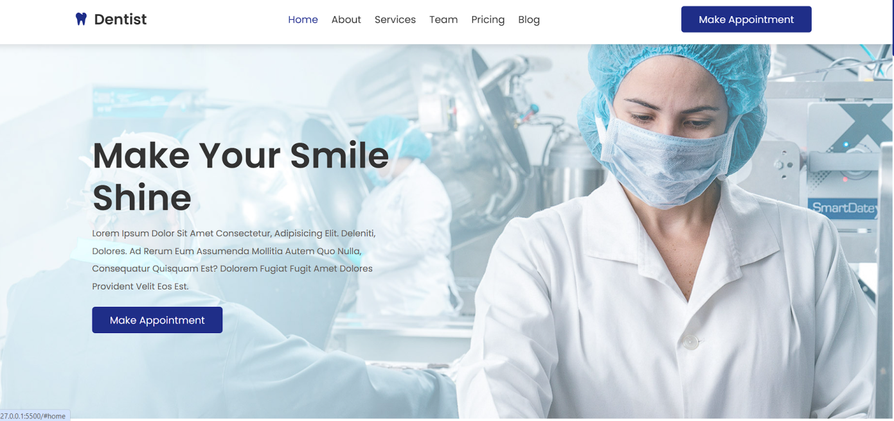

**About:**

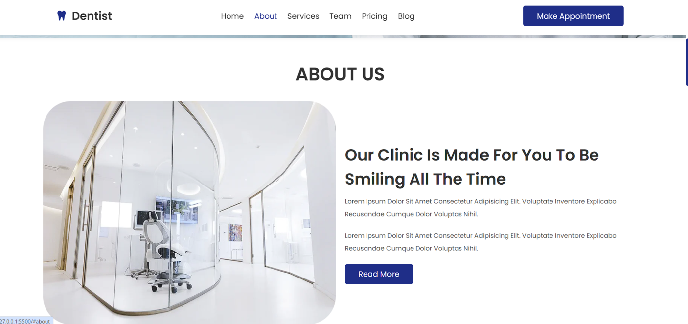

**Services:**

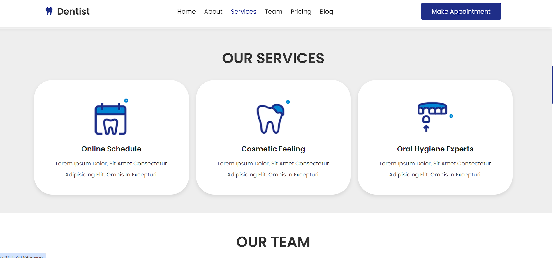

**Team:**

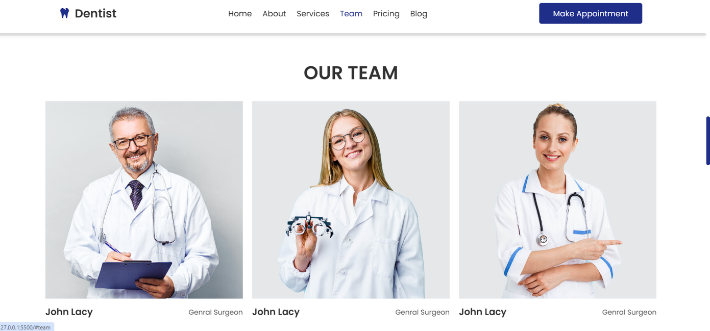

**Pricing:**

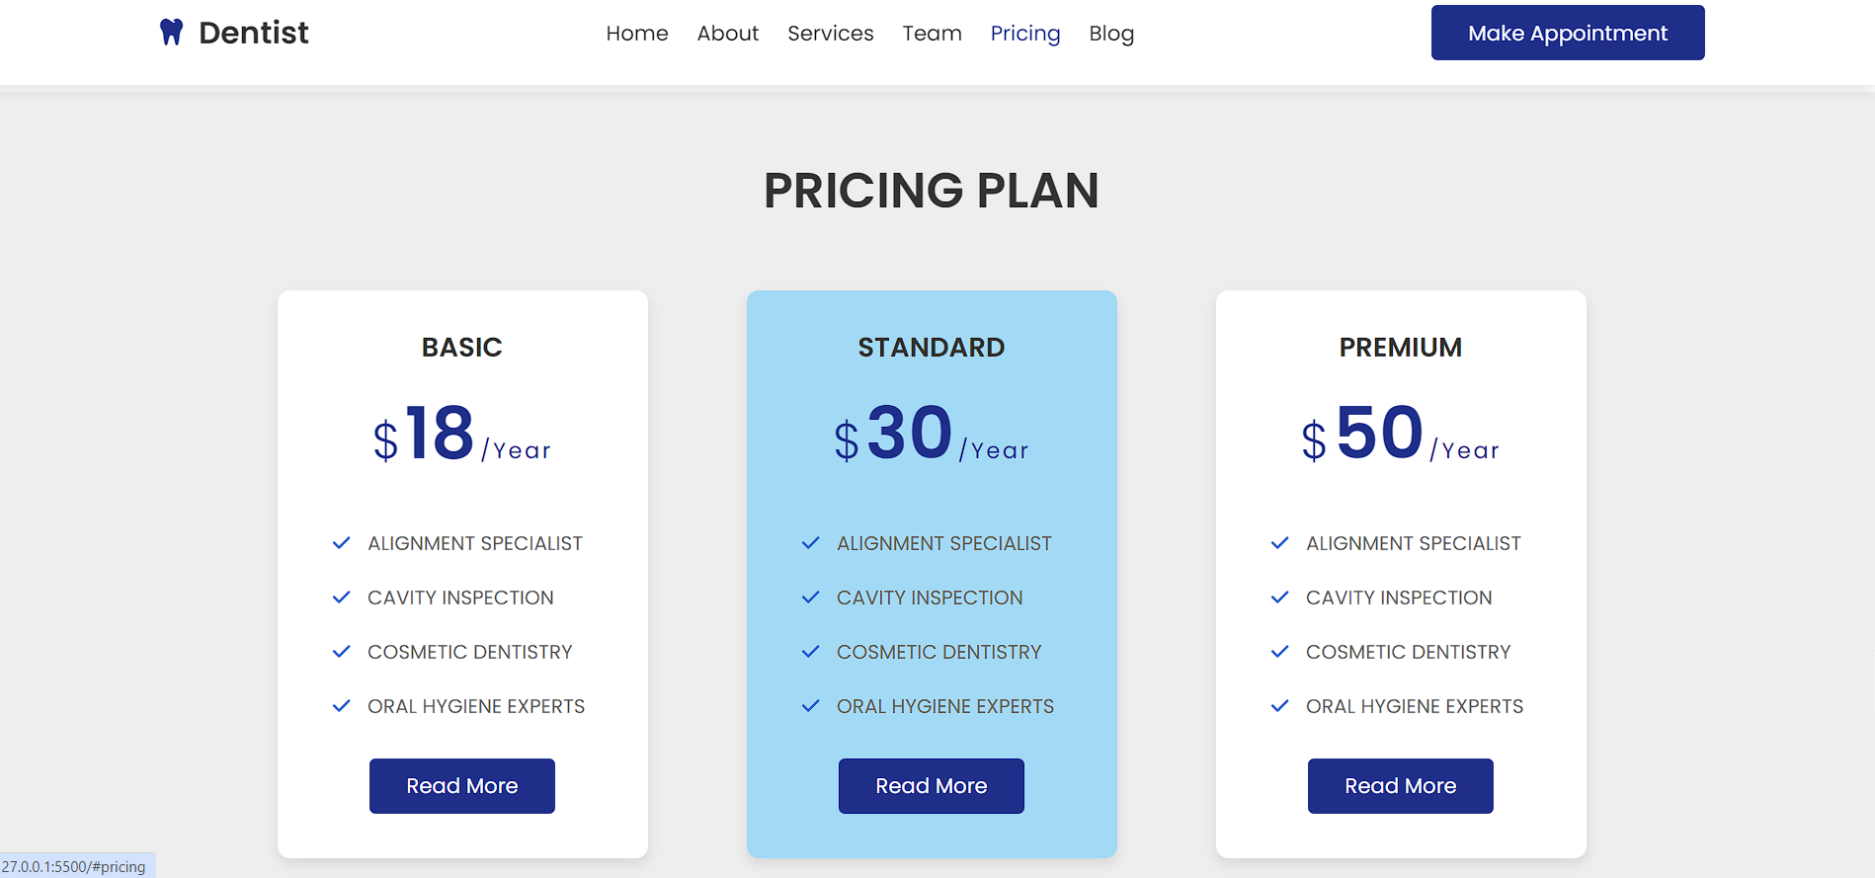

**Blog:**

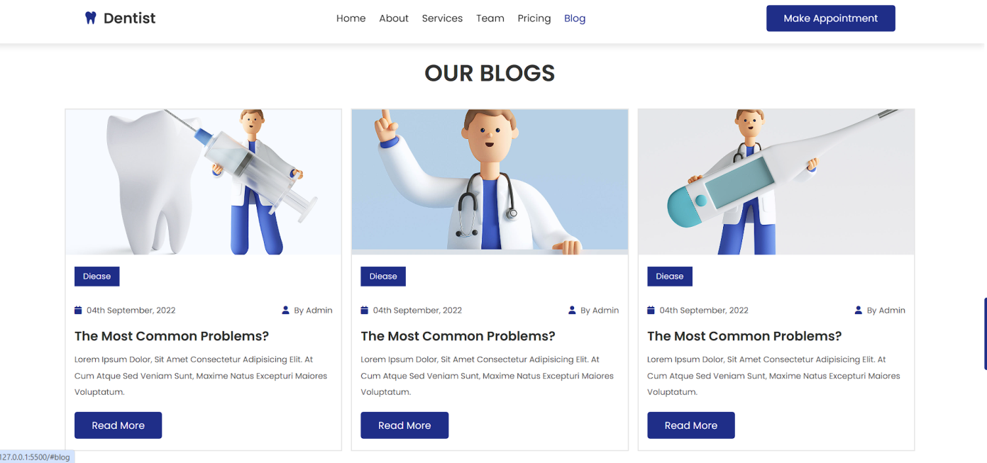

**Make appointment:**

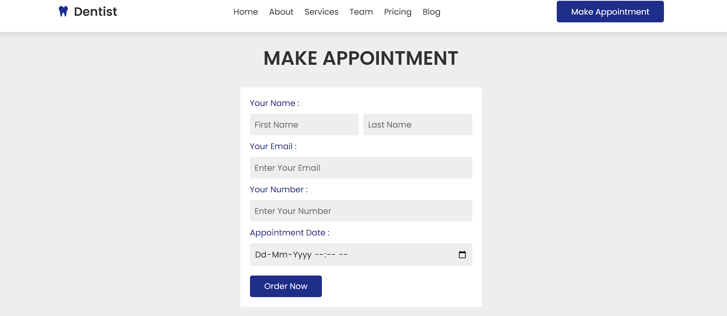

**CONTACT:**

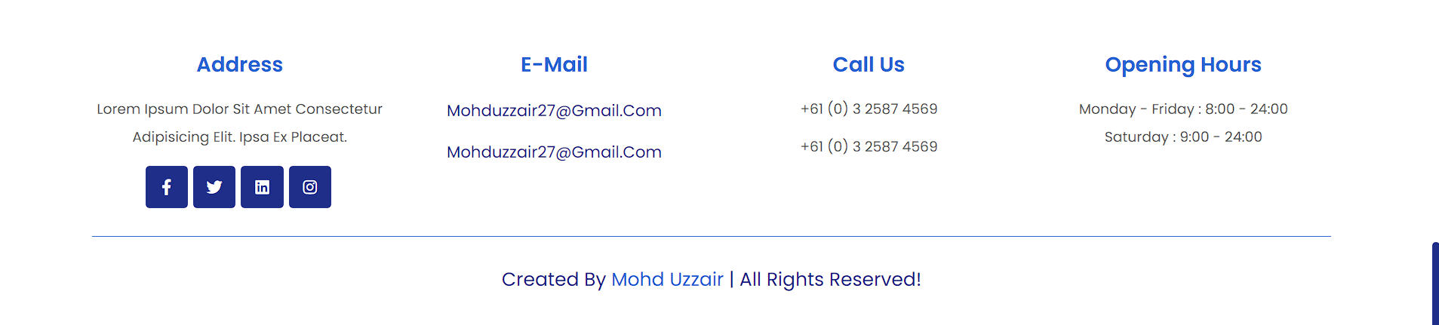

JGGG

**CONCLUSION & FUTURE  
SCOPE**

**CONCLUSION:**

The dentist website has been successfully developed to provide essential information to patients about services, dental care tips, and appointment scheduling. It serves as a valuable resource for both existing and potential patients, enhancing their overall experience with the dental practice. Through user-friendly design and informative content, the website aims to build trust and credibility with visitors, ultimately leading to increased patient engagement and satisfaction.

"In conclusion, our dental practice is committed to providing exceptional care to our patients, utilizing the latest technology and techniques to ensure optimal oral health. With a focus on patient comfort and satisfaction, we strive to create a welcoming environment where every individual feels valued and cared for. Whether you're in need of a routine check-up or a more complex procedure, our team is here to serve you with professionalism and compassion. Thank you for considering us for your dental needs."

In conclusion, our dental practice is committed to providing exceptional oral care to our patients. With a team of experienced professionals and state-of-the-art facilities, we offer a comprehensive range of services to cater to all dental needs. Whether it's routine check-ups, cosmetic dentistry, or emergency care, we prioritize patient comfort and satisfaction above all else. Contact us today to schedule an appointment and experience the difference in your dental health journey

**FUTURE SCOPE:**

**Online Appointment Booking System:** Implementing a more advanced and interactive appointment scheduling system can streamline the booking process for patients, allowing them to select specific dates and times based on the dentist's availability.

**Patient Portal:** Introducing a secure patient portal where individuals can access their medical records, treatment plans, and make payments online can enhance convenience and improve communication between patients and the dental practice.

**Virtual Consultations:** Incorporating telemedicine capabilities to enable virtual consultations can cater to patients who prefer remote access to dental advice and initial assessments, especially in situations where in-person visits may be challenging.

**Interactive Education Resources:** Expanding the website's educational resources section with interactive videos, infographics, and FAQs can empower patients to take better care of their oral health and understand various dental procedures more comprehensively.

**Integration with Social Media:** Integrating social media platforms into the website can facilitate broader outreach, engagement, and community-building among patients. Regular updates, testimonials, and interactive Q&A sessions can foster a sense of belonging and trust.

**Multilingual Support:** Adding multilingual support to the website can cater to a more diverse patient demographic, ensuring accessibility and inclusivity for individuals who speak languages other than the primary language of the website.

**Mobile Application Development:** Developing a dedicated mobile application can offer additional features such as appointment reminders, oral health tracking tools, and real-time notifications, further enhancing patient engagement and retention.

**Continued Website Optimization:** Regularly updating and optimizing the website based on user feedback, analytics data, and emerging trends in web design and user experience can ensure that it remains relevant, intuitive, and effective in meeting the needs of both patients and the dental practice.

By incorporating these future enhancements, the dentist website can continue to evolve as a comprehensive platform for delivering quality dental care services while staying ahead in an increasingly digital-driven healthcare landscape. run the entire work in a much better, accurate and error free manner.

**BIBLIOGRAPHY**

**BOOKS:**

* HTML and CSS: Design and Build Websites by Jon Duckett
* Learning Web Design: A Beginner's Guide to HTML, CSS, JavaScript, and Web Graphics" by Jennifer Niederst Robbins
* HTML5 Pocket Reference by Jennifer Niederst Robbins
* "HTML5 for Web Designers" by Jeremy Keith
* Head First HTML and CSS" by Elisabeth Robson and Eric Freeman
* CSS Secrets: Better Solutions to Everyday Web Design Problems" by Lea Verou
* CSS: The Missing Manual" by David Sawyer McFarland
* CSS Mastery: Advanced Web Standards Solutions" by Andy Budd, Cameron Moll, and Simon Collison
* Responsive Web Design with HTML5 and CSS3" by Ben Frain

**ONLINE REFERENCE:**

* [www.youtube.com](http://www.youtube.com/)
* [www.w3schools.com](http://www.w3schools.com/)
* [www.wilipedia.com](http://www.wilipedia.com/)
* [www.geeksforgeeks.com](http://www.geeksforgeeks.com/)
* [www.beginnersbook.com](http://www.beginnersbook.com)